Moving Memorials – railways and commemoration

A study by Philip Dunn Birch, volunteer researcher, National Railway Museum. 2016

This document contains information on war memorial locomotives, nameplates, EMU’s and etc. from the United Kingdom and around the world, except the USA. Information was sourced principally from the binders, books and newspaper articles in Search Engine, National Railway Museum, York and on-line in 2016.

CONTENTS

1.0 Historical Background

2.0 Memorial Locomotives/EMU/Sculptures, U.K.

2.1 “Valour” Great Central Railway

2.2 “Valour” GB Railfreight 66715

2.3 “Patriot” LNWR

2.4 “Patriot” London Midland and Scottish Railway

2.5 ”The Unknown Warrior” 45551, new build ‘Patriot’

2.6 “Patriot” 87003 British Rail

2.7 “Patriot, in memory of fallen railway employees”

2.8 “Lest we forget”

2.9.1 “Remembrance”, London, Brighton and South Coast Railway

2.9.2 “Remembrance”, Southern Railway and British Railways

2.9.3 “Remembrance”, South Eastern Class 465 EMU

2.10 “Remembrance”, Royal Engineers WD 90773 plus ”Big Jim” USTAC 2-8-0 5820, Worth Valley Railway

2.11 “Singapore”, Rutland Railway Museum

2.12 “Axe”, Lynton and Barnstaple Railway

2.13 Class 91’s East Coast

2.13.1 91110 "BATTLE OF BRITAIN MEMORIAL FLIGHT”

2.13.2 91111 “For the Fallen”

2.14 Southeastern Class 395, Javelins

2.14.1 395 014 “The Victoria Cross”

2.14.2 395 015 “Live On”

2.14.3 395 016 ‘Somme 100’

2.14.4 395 017 ‘Passchendaele’

2.14.5 395 018 ‘Victory’

2.15 Great Western, Harry Patch H.S.T. 2016

2.16 Freightliner 66 614 “Poppy” November 2016

2.17 Railfreight Class 66 418 “Patriot’ as part of ‘Project Honour” 2016

3.0 Special Railway Memorials

3.1 Railway Industrial Memorial, National Arboretum, Alrewas, Staffs.

3.2 Burma Railway, National Arboretum, Alrewas, Staffs.

3.3 Sumatra Railway, National Arboretum, Alrewas, Staffs.

4.0 Memorial locomotives, the rest of the world

4.1 Passchendaele, Ab 608 Pacific, New Zealand Railways

4.2 Ov 7024 0-8-0, Russian Railways Locomotive

4.3.1 MK3 244 2-8-2 at Imjingak War Memorial, South Korea

4.3.2 The MT-2 at Imjingak War Memorial, South Korea

4.4 “Hero” Great Indian Peninsular Railway, D4 Class 4-6-0

4.5 Australian War Memorial R.O.D. 4-6-0 Narrow gauge tank engine

1.0 HISTORICAL BACKGROUND

War Memorial Locomotives are not common. Although there are many locomotives that have been named after battles, regiments and soldiers, particularly in the United Kingdom, there are few that are regarded as War Memorials. Across the world few countries name or have named locomotives.

The UK has a long tradition of naming locomotives right from the start of powered railways. However today fewer trains are being named as more and more of our trains become fixed units – either EMU’s or DMU’s. In addition, many of the train operating companies have removed nameplates and not replaced them.

A relatively new trend is the use of decorative vinyl. SouthEastern Javelins, Class 91’s and H.S.T’s have been covered in decorative vinyl in recent times, some with accompanying cast nameplates.

In November 2016, UK freight companies added some more nameplates to Class 66’s including “Poppy” and “Patriot”

2.0 War Memorial Nameplates and Locomotives/ EMU’s etc.

There are thousands of Locomotives/E.M.U.’s/D.M.U.’s and many named locos but very few War Memorial named trains or locomotives.

2.1 **Valour**, Great Central Railway

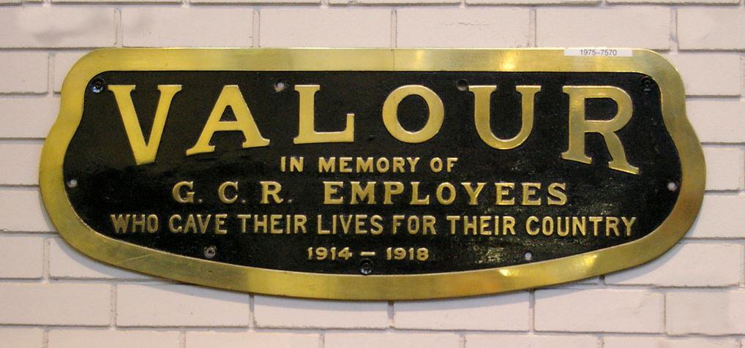

The nameplate was initially fixed to a Robinson designed ‘Lord Faringdon’ class (GCR 9P, LNER Class B3), built in 1920*, as No.1165, then 1496 and finally LNER 6165. The engine was withdrawn on December 31st 1947, the very last day of the existence of the LNER.

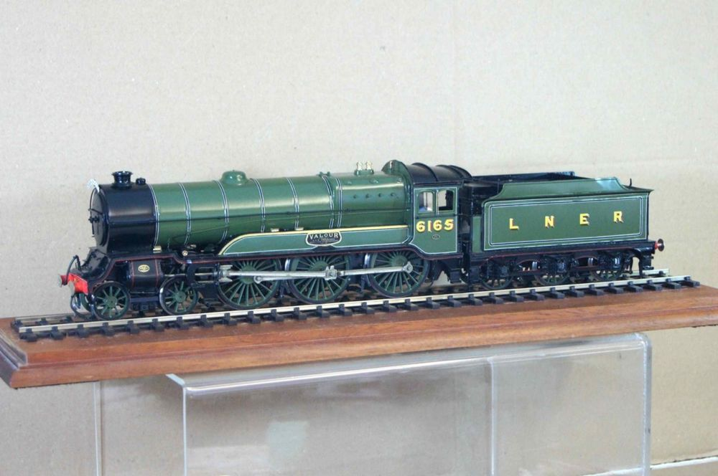

Model of the Great Central locomotive ‘Valour’ as LNER 6165

From 1922 until 1938 at every November 11th commemoration an immaculate ‘Valour’ was at Sheffield Victoria Station near to the site of the Great Central War Memorial on Sheffield Victoria station, with a wreath around the nameplate. One year she arrived in less than pristine condition, but it never happened again after the Divisional Manager let his thoughts be known.

When the locomotive was withdrawn in 1947 and scrapped, one of the nameplates was placed in St Barnabas Church, Openshaw, close to Gorton Works, Manchester, where the locomotive was built. Unfortunately, this nameplate has 'disappeared'

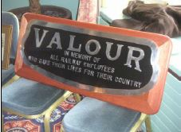

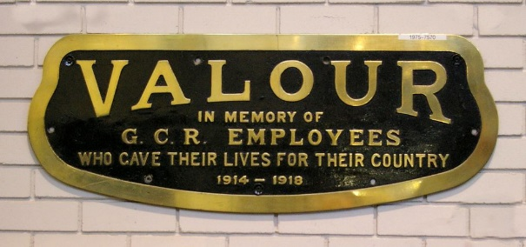

2.2 **Valour**, 66 715 GB Railfreight, 2003

In 2003 diesel locomotive, no.66 715, operated by freight company GB Railfreight, was named “Valour, in memory of all railway employees who gave their lives for their country” at a ceremony on 11th Nov.2003 in Sheffield.

The naming was part of a special ceremony that marked the removal of the Great Central Railway War Memorial to its present position in the square at the front of the Royal Victoria Hotel, following rededication of the war memorial. After the rededication, 66715 was named Valour by Mike Hartley, Chairman of the Great Central Railway Society and Ward Simpson then General Manager of GB Railfreight.

The locomotive was dedicated as a war memorial by the Dean of Sheffield, the Very Reverend Peter Bradley. 66715 ‘Valour’ continues to honour the railwaymen and women who fell in the First World War and subsequent conflicts. An identical plate to those carried by 66715 can be seen inside the hotel lobby.

Ken Grainger of the Great Central Railway Society said: “From 1922 until 1938 the centre piece of the annual Armistice Day commemoration had been the G.C.R.'s war memorial locomotive, the express passenger 4-6-0 `Valour'. Sadly, the original `Valour' is no more, but, as the culmination of the 2003 ceremony, the G.C.R.S. was delighted that GBRf locomotive no. 66715 was named as the new `Valour' and dedicated as a war memorial in its own right. Thanks to First GBRf we once again have a focal point for the honouring of the Great Central Railwaymen who made the ultimate sacrifice in the service of their country.

GBRF 66 715 locomotive ‘Valour’ continued the work of its namesake, the 1920s class 9P ‘Lord Faringdon’ passenger locomotive, by taking part in act of remembrance at London Marylebone railway station 11th Nov. 2008. Dressed with a large poppy ‘Valour’ pulled into platform three at the station in central London to start the memorial proceedings.

2.3 **Patriot** L.N.W.R.

LNWR 5XP 4-6-0 Claughton class No 5964, named 'Patriot' in remembrance of the LNWR employees who died in the Great War. Built at Crewe works in January 1920 it was given the number 1914 which it retained until June 1926 when the LMS No 5964 was applied. It remained in service until July 1934 when it was retired from service for scrapping at Crewe. When Claughton class No 5964 was scrapped the name was transferred to LMS No 5500 thereby continuing to honour the men of the 1914-18 war and providing a class name.

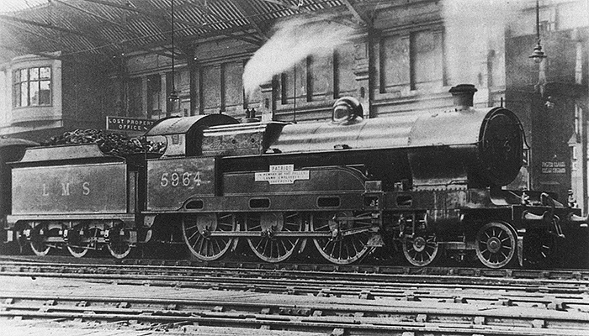

2.4 Patriot L.M.S.

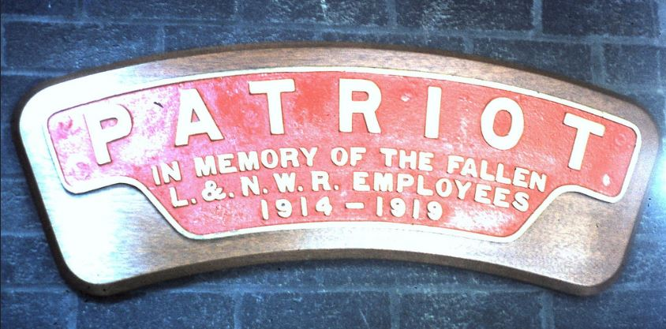

The LMS Patriot Class was a class of 52 express passenger steam locomotives built for the London Midland and Scottish Railway

The first two were rebuilt in 1930 from the 1912-built LNWR Large Claughton class at Derby, retaining the original driving wheels with their large bosses, the "double radial" bogie truck and some other parts. The engine that was to become Patriot, 5971, was originally called ‘Croxteth’.This retained its original number until 1934, when it was renumbered 5500. In November 1937 it was renamed “Patriot”. Although they were called ‘Patriots’ they were also known as ‘Baby Scots’ until their withdrawal. “Patriot” was withdrawn in March 1961. Many were not named or did not receive their names.

2.5 Patriot 45551, **The Unknown Warrior**

In 2007 a proposal to build a new LMS Patriot, using the surviving drawings, was published in the 13th July issue of Steam Railway magazine. This led to the formation of a Limited Company with charitable status. The number of the loco was (4)5551. The new ‘Patriot’ will be named ‘The Unknown Warrior’ in keeping with the tradition of war memorial engines.

2.6 BR No. 87 003 **‘Patriot’**

Built by BREL Crewe Works in July 1973, this loco worked its entire life on the west coast main line. 36 class 87 AC electric locomotives were built to work services when the line was electrified from Preston to Glasgow in 1973. They were the flagships of British Rail's electric locomotive fleet until the late 1980s with a power output of 5,000 bhp, 3730 Kw.

The locomotive was named "Patriot" on 13 June 1978 at London Willesden MPD without ceremony and a simple nameplate that did not include remembrance lines. It commemorated the LMS Patriot class steam locos used on the WCML, built 1930-34 by LMS at Derby and Crewe and designed by Sir Henry Fowler.

Withdrawn in December 2007 this loco was one of those exported to Bulgaria; leaving as part of a batch of 87’s in December 2008 but with the nameplate removed.

2.7. 66 418 **‘Patriot – in memory of fallen railway employees’**

Freightliner No.66 418 “Patriot” named as part of Project “Railway Honour” on the 11th Nov. 2016

2.8 66 413 **‘Lest We Forget’** – GB Railfreight locomotive named in commemoration of 100 years since the ending of the First World War with a commemorative roundel above the nameplate saying ‘Thank you’.

2.9.1 **Remembrance**

Locomotive 333 was built originally by the London Brighton and South Coast Railway, designed by L.B. Billington, as an L class 4-6-4 ‘Baltic’ tank, the last entirely new locomotive design of the London, Brighton and South Coast Railway. 333 entered traffic in 1922 painted in grey with black bands and white lining and white lettering and numbers, blocked in black, and remained in this livery until painted green by the Southern Railway.

The name “Remembrance” was painted on the side tanks as the Brighton Company's War Memorial engine and it carried a plaque inscribed "In grateful remembrance of the 532 men of the L.B.& S.C.Rly. who gave their lives for their country, 1914-1919"

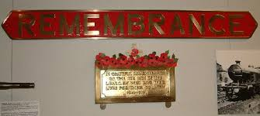

2333 kept its painted name when it became part of the Southern Railway but eventually straight nameplates were attached to the tanks above the plaque.

2.9.2 **Remembrance** Southern Railway (Maunsell) N15x Class 4-6-0



In June 1935, under the auspices of Richard Maunsell No. 2333 was rebuilt as a Class N15x 4-6-0 and fitted with a standard Urie LSWR tender along with smoke deflectors. Number 2333 ‘Remembrance’ retained its name with a curved nameplate and the plaque on the splasher. It was withdrawn in April 1956.

|  |  |
| --- | --- |
|  | James Petts wrote:  The LBSCR "L" Class is incorrectly named as "Remembrance". In fact, this was not the name given to the class: they were informally termed the "Brighton Baltics", as they were tank locomotives of the Baltic wheel configuration that ran on the Brighton expresses. Since the class were introduced in April 1914 the class was built (and thus named) before the outbreak of World War I. The class were built until 1922, and one of the later members of the class was called "Remembrance", but that name was only ever a name applied to one individual member.   However, in the mid-1920s, the class were rebuilt as 4-6-0 tender locomotives by the Southern Railway,and given the class name N15X. These locomotives, not the LBSCR "L" class were known as the "Remembrance" class. Ref. <http://forum.simutrans.com/index.php?topic=5590.0;wap> |

2.9.3 **Remembrance**, South Eastern Class 465 E.M.U.

The "Remembrance" nameplate on the second car of Class 465 ‘Networker’ ‘ 465 903, was unveiled on the 13th June 2008 by William Stone aged 105, the last UK resident to serve in both World Wars.

2.10 Royal Engineers, 8F Memorial Locomotive

WD 307 / LMS 8233 / ISR 41.109 / BR 48773

Locomotive 48773 is a dedicated war memorial. WD 307 was built in 1940 by the North British Locomotive Co. as part of a War Department order for locomotives intended for service in France. After the Fall of France, the locomotives were instead loaned to the LMS Railway to help with wartime freight traffic and WD 307 was renumbered 8233. By December 1941, No. 8233 and over 140 other Stanier 8F heavy freight locomotives had been requisitioned by the WD.

These locomotives were sent to Persia (Iran) to supply the Soviet Union with vital supplies along a difficult route from the Gulf Ports, run by the Railway Sappers of the Corps of Royal Engineers. In 1946 it was loaned to Egyptian State Railways for two years. After returning to the UK in 1952 for overhaul, it was stored on the Longmoor Military Railway (Hampshire) until purchased by British Railways in 1957. Renumbered 48773, the locomotive was used in Scotland and the North West of England for the next 11 years. In 1968, after strenuous efforts by Society members, No. 48773 was purchased for preservation and moved to the newly-formed Severn Valley Railway.As a locomotive with a unique military history, it was suggested that it should be dedicated as a Memorial to those military railwaymen of the Corps of Royal Engineers (Transportation) who lost their lives in World War II.

In 1986 a Service of Dedication was held at Highley, on the Severn Valley Railway, led by the Dean of Hereford, and conducted with full Military Honours. In 2002 the Society compiled a Roll of Honour and Books of Remembrance commemorating 354 known casualties. The dedication was made by the Chief Royal Engineer, Lieutenant-General Sir Scott Grant KCB, at a Service held at Kidderminster Station (SVR). Commemorative plaques on the loco record its operation by the Corps of Royal Engineers in Persia (Iran) and Egypt in W.W 2.

2.10 WD 2-8-0 90733 named for the day “Remembrance”

plus “Big Jim” USTAC 2-8-0, 5820

As part of the Haworth 1940’s Weekend in commemoration of the D-Day landings 70 years before, at 9.30 on Saturday 17th May 2014, Haworth Locomotive Works was witness to the ceremony of thanksgiving for the restoration of wartime locomotives WD 90733 2-8-0 from the UK, named for the day ‘Remembrance – less we forget’, and USTAC 2-8-0 5820 from the USA. To remember those men and women from the Second World War who worked on their sister engines and those who were transported to the areas of war by them.

2.11 **Singapore**, Hawthorn Leslie 0-4-0

Singapore is a Naval Dockyard steam locomotive captured along with 80,000 allied servicemen by the Japanese on the fall of Singapore in February 1942. It was built by Hawthorn Leslie in 1936 and purchased for the Admiralty Dockyards in Singapore where it was named. It was repatriated to Chatham in December 1953. It is now at ‘Rocks by Rail, the Living Ironstone Museum’ Cottesmore, Oakham, Rutland.

The locomotive displays war damage and has memorial plaques dedicated to the courage, sacrifice and comradeship of the Allied servicemen who suffered at the hands of the Japanese as Prisoners of War in the Far East 1941-1945. The locomotive was recently included as a registered War Memorial in a survey of the east midlands.

2.12 **Axe**, Kerr Stuart No 2451

Kerr, Stuart & Co Ltd No. 2451 was built at Stoke-on-Trent in 1915. A side and well tank locomotive, it was one of seventy 60cm gauge "Joffre" Class (named after the French First World War Commander) ordered by the French government for service on the Western Front.

Around 1956, 2451 along with four sister locos, was found lying derelict by British enthusiasts at Rinxent about 12 miles from Calais, having been out of service for almost ten years.

In 1974 all five locos were repatriated to the UK. No. 2405 went to the West Lancashire Light Railway near Southport. The others including 2451 by 1976 were stored at the Pen-yr-Orsedd Quarry Museum in North Wales and later in 1978 at Gloddfa Ganol, Blaenau Ffestiniog where 2442, 3010 and 3014 were given a coat of paint, while 2451 remained unpainted - see photo below.

Purchased by the Lynton & Barnstaple Railway Association in 1983 for £2750 and christened ‘Axe’ in line with the L&B's policy of naming its locos after three-letter Devon rivers. She was eventually transferred to the Gartell Light Railway at Templecombe in Somerset who completed the restoration work.

‘Axe’ first steamed at the railway as part of a dedication ceremony by the Bishop of Exeter on November 11th 2008. With eventual completion in January 2009, she arrived back at the railway for steam trials and hauled her first revenue earning passenger service on March 1st 2009.

Every year children from several local schools visit Woody Bay station on the restored section of the Lynton and Barnstable Railway to take part in a commemoration of not only the Armistice signed between the Allies of World War I and Germany at Compiègne, France, for the cessation of hostilities on the Western Front in 1918, but also to remember all service personnel who lost their life in war zones - including present day conflicts.

This takes place at eleven o'clock in the morning - the "eleventh hour of the eleventh day of the eleventh month" - and is particularly poignant as Axe was engaged in the hostilities in France during the 1914/18 war. ‘Axe’ carries a plaque as a permanent record of her dedication in 2008 by the Bishop of Exeter "To all those who served on the railways of the western front in the Great War

2.13.1 91110, **‘Battle of Britain Memorial Flight’**

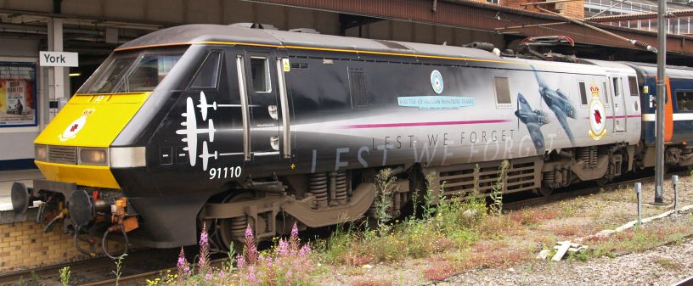

In a ceremony on the opening day of the National Railway Museum’s nine-day ‘Railfest 2012’ exhibition, the new look of loco No. 91110, was unveiled as three aircraft from the Battle of Britain Memorial Flight (BBMF) – a Spitfire, Hurricane and Lancaster – made a pass overhead. TV Presenter Carol Vorderman unveiled the striking new and unique livery

The loco has a vinyl wrap that shows a specially-designed livery featuring the three planes, the Royal Air Force roundel, RAF BBMF insignia and ‘Lest We Forget’ motto.

The loco’s nameplate is of similar style to those fitted to O.V. Bulleid’s ‘Battle of Britain’ steam locos that were constructed from 1946.

91 110 (formerly 91 010) holds the UK national speed record for electric traction, achieved on Stoke Bank, north of Peterborough, on 17 September 1989 at 161.7 mph (260.2 km/h) and carries a commemorative plaque.

2.13.2 – 91 111 **“For the Fallen”**, 2014

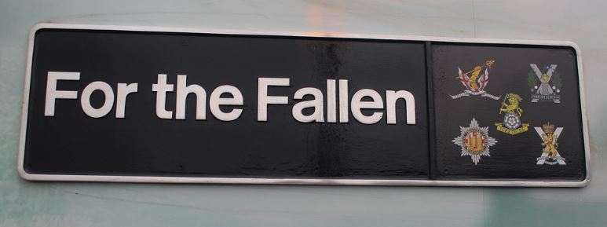

The locomotive bears a name plate which includes the cap badges of five Regiments. On one side the badges are those of the Regiments as they were in World War One - the opposite side shows the cap badges of today’s successor regiments.

London - 1914 Honourable Artillery Company / 2014 Honourable Artillery Company

Yorkshire - 1914 Royal Dragoon Guards / 2014 Royal Dragoon Guards

1914 Green Howards / 2014 Yorkshire Regiment

Newcastle - 1914 Tyneside Scottish (NF) / 2014 Tyneside Scottish (RA)

Edinburgh - 1914 Royal Scots / 2014 Royal Regiment of Scotland

A dedication ceremony at Newcastle Central Station, witnessed by civic and military leaders and veterans and serving soldiers took place on the 14th October 2014 following a ceremony of remembrance held at King’s Cross Station to mark the centenary of the First World War on the 7 November 2014. Secretary of State for Transport Patrick McLoughlin was joined by 100 serving and retired military personnel who gathered to greet East Coast locomotive 91111 “For the Fallen”. The ceremony included Mark Carne (Chief Executive Network Rail), Michael Holden (Directly Operated Railways Chief Executive), Karen Boswell (Managing Director of East Coast Trains), Patrick McLoughlin MP (Secretary of State for Transport) and Michael Portillo.

2.14. South Eastern **‘Poppy Trains’**

Class 395 ‘Javelins’ were built by Hitachi in Japan and started work in 2009. They formed part of the transport link for the London 2012 Olympics – hence the name. They are the first Japanese built train in the UK and are based on the Shinkansen 400. They are Britain’s fastest domestic train at 140 mph.

From 2014 an annual charity rail tour, run by UK Railtours, Southeastern Railway, and various industry partners, has run to raise funds for the Royal British Legion’s Poppy Appeal in November. The vinyl are then kept on the vehicle for a year. The trains were the idea of Southeastern employees Andy Harding, a Cl395 fleet engineering manager, based at Ashford and Kent Evenden, a high-speed driver manager.

2.14.1 **2014 – 2015** 395 014 “The Victoria Cross”

Unit 395014 was named to mark the centenary of the start of the First World War and given a unique design featuring the Victoria Cross and the Royal British Legion's poppy. On the 25 March 2015 it made a special stop at London St Pancras International on to deliver over £25,000 for The Royal British Legion. The money from a commemorative charter train in November 2014 which took in London, East Kent and parts of the network it would normally bypass. The train arrived on Platform 13 at London St Pancras International, to mark 13 years of UK military operations in Afghanistan. Members of the Royal British Legion recieved a cheque for £25,385, the proceeds from ticket sales, donations and funds raised through onboard raffles.

2.14.2 **2015 – 2016** 395 015 “Live On”

The rail tour in 2015 ran with 395014 and 395015 together on a rail tour called ‘Operation Javelin’. The 2015 train saw poppies on the exterior paintwork at the front of the train, a large poppy next to the first door on the cab and a large display further back emblazoned with the message: ‘LIVE ON: To the Memory Of The Fallen and The Future of the Living.’

2.14.3 **2016 – 2017** 395 016 ‘Somme 100’

Nov. 2017 Southeastern ran 395016, ahead of Remembrance Sunday to mark 100 years since the Somme with ‘Somme 100’ vinyls.

2.14.4 **2017- 2018** 395 017 ‘Passchendaele’

The 2017 rail tour, had 395017 unit named Passchendaele. 395016 “Somme 100”, the previous year’s Javelin railtour unit, was retired from this guise at the end of the day.

2.14.5 **2018 -2019** – 395 018 ‘Victory’ featuring a ‘Winged Victory’ statue holding a symbol of peace.

2.15 Class 43, HST 43 172 **‘Harry Patch’**

The class 43 set a world record for the maximum speed of a diesel train of 148 mph (238 km/h), and operate in regular service at speeds of 125 mph (201 km/h). Introduced in 1975 they transformed inter-city travel on non-electrified routes. They were re-engined with MTU power units from 2005

43 172 was named after Britain’s last survivor of the World War One trenches who died in 2009. The engine's livery incorporated the words from Laurence Binyon's ‘Ode to Remembrance’. His particular friend’s nicknames, Jack, Jilly and Maudy are also featured within the design. By the time Mr Patch died in July 2009 aged 111, he had become a national hero symbolising the ordinary soldiers who gave their lives. The nameplate was unveiled at Bristol Temple Meads on the 6th Nov.2015 by Mr Patch's grandson.

2.16 66 614 **‘Poppy’**

Freightliner locomotive 66 614 was named in memory of workers from Buxton Lime Firms who lost their lives in the battle in Nov. 2016. 15 workers from Buxton Lime Firms (now Tarmac) who served and died in the Battle of the Somme in 1916. The naming ceremony took place at Tarmac’s Tunstead Quarry.

2.17 66 418 **‘Patriot’**

Project “Railway Honour” in 2016 saw Freightliner name 66 418 **"PATRIOT - IN MEMORY OF FALLEN RAILWAY EMPLOYEES"** in a private ceremony at their Crewe Basford Hall depot on Armistice Day, 11th November 2016. The 66 was named in association with ABF The Soldiers’ Charity - The National Charity of the British Army and carries a plaque below the nameplate in recognition of this. This class 66 naming is a modern-day link back to the 'Claughton' and 'Patriot' memorial steam locomotives from the 1920s and 1930s.

3.0 Special Railway Memorials

3.1 The Railway Industry Memorial “8F”, 2012

National Arboretum, Alrewas, Staffordshire.

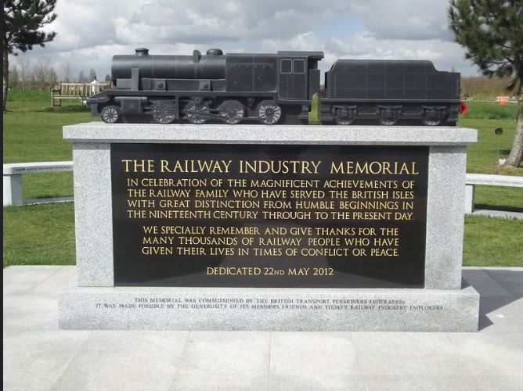

The National Memorial Arboretum at Alrewas (near Lichfield) in East Staffordshire is the UK national site of remembrance.  On Tuesday 22nd May 2012, following an ambitious project led by the BTPF British Transport Pensioners' Federation, a memorial to the Rail Industry was unveiled.

3.2 **Burma Railway**

The memorial is constructed from 30 metres of the original rails and sleepers from the Burma railway which were brought to the arboretum from Thailand in HMS Northumberland in 2002.

The memorial is a permanent tribute to those who were forced to construct the infamous ‘Railway of Death’ and the benches and trees around the railway track have relevant dedications. The memorial was dedicated on 15 August 2002.

3.3 **Sumatra Railway**

The memorial to the Sumatra Railway, is at plot 228. The Sumatra railway was constructed in extreme conditions around the Equator, by 5,000 allied prisoners of war, and 30,000 local people. The railway was completed on August 15th 1945 (VJ – Day), so it was never used apart from transporting the prisoners of war back to civilization. Along the track bed are some of the tools, used in the original construction.

4.0 Memorial Locomotives - the rest of the world (excluding the USA)

4.1 New Zealand Railways Ab 608 Pacific, 1925, ‘**Passchendaele’**

In 1925 the New Zealand Minister of Railways, Gordon Coates, agreed to a proposal to name a steam locomotive ‘in memory of those members of the New Zealand Railways who fell in the Great War’. It was decided to name the very first production Ab, number 608, in honour of the railway men who died during World War One (at the time, simply known as the Great War).

More than 5000 NZ railwaymen served overseas between 1914 and 1918 (out of a total workforce of 14,000), and 447 were killed. After considering the names Somme, Le Quesnoy and Ypres, Coates chose Passchendaele. There had been no named locomotives in New Zealand since (perhaps) the F Class of the 1870's.

Ab608 was fitted with handsome bronze pates above the centre driving wheels. During World War Two the plates were removed and the locomotive was not reunited with its plates until the 1960's.

In 1967, Ab608 was preserved. Ab 608 was re-commissioned on 25 April 2014 is now operational and mainline certified.

4.2 Russian War Memorial Locomotive Ov 7024 0-8-0

OV 7024 is both a war memorial and a memorial to workers who repaired it at the first Communist Subbotnik on 12 April 1919 (when workers voluntarily did work on a Saturday – Russian ‘Subota’). 7024 is plinthed at Moskva-Ryazanskaya, Sortirovochnaya depot,.

4.3.1 South Korea – D51 No. 244 2-8-2, Japan c/1944

The D51 locomotives numbered 1115 and were built 1936 - 1951. Designed by Hideo Shima, later the ‘father of the Shinkansen’ Imjingak, South Korea No.244 is on display at Imjingak, South Korea which is a memorial to the war and the division it created.

4.3.2 The Mikasa MT2 4-8-2 No.244 at Imjingak

Built Nippon Sharyo 1943 and destroyed in the Korean War. A derelict locomotive recovered from the de-militarised zone (DMZ) and also on display at Imjingak, South Korea.

This loco sat abandoned where it was blown up in the DMZ for 56 years until moved to the "Peace Park" in the DMZ on the border where it is best described as "conserved" rather than "preserved".

4.4 **‘Hero**’ No. 411, D4 4-6-0, 1920, Great Indian Peninsular Railway.

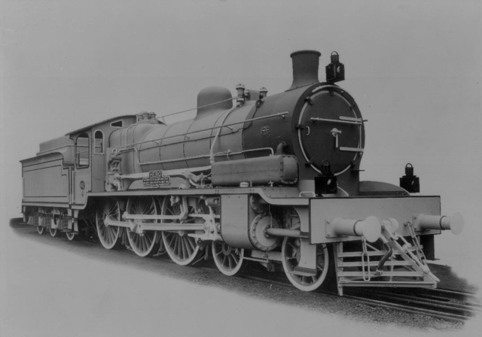

(Image and details from <http://www.enuii.org/vulcan_foundry/> )

No. 411 Hero, a 4-6-0 locomotive of the D4 class was built by Vulcan Foundry for the Great Indian Peninsular Railway in 1920. In common with several other railways, the Great Indian Peninsula Company commemorated those of its servants who died during the Great War by attaching a symbolic name and inscription to one of is express engines.

The locomotive bore the name “Hero” and is inscribed: “In memory of G.I.P. railway employees who gave their lives in the Great War, 1914-1918.”

4.5 Australian War Memorial R.O.D No. 306 narrow-gauge tank engine.

Formerly ROD 306 and later used by Gin Gin Mill, Bunderburg, Queensland.  ROD 306 had been privately preserved in an operational condition during the 1980's, and was later stored at Wee Waa, NSW until purchased in late 2001 by the Australian War Memorial, Canberra.

ROD 306 was restored for static display at the Australian War Memorial's Treloar technology centre and unveiled on 23rd February 2004.

7.0 Conclusion

There is limited information about war memorial Locomotives from World War1 up to the Korean War, and this is mostly from the United Kingdom. Naming of locomotives was rare in other countries and designating them as war memorials seems equally rare. If the locomotives that celebrated battles and individuals of the wars were added then this list would have been much longer.

Overseas, countries with large numbers of locomotives seem to have had no ‘memorial’ engines until the ‘Gulf Wars’ of the 1990’s.

After the second Gulf War to the present day the U.S.A started to paint and then vinyl locomotives and trains to commemorate members of the armed forces who had lost their lives and those who had served in the conflict.

8.0 Sources

[Book of Remembrance: Railway Transportation Units of the Corps of Royal Engineers, World War II.](http://yorsearch.york.ac.uk/primo_library/libweb/action/display.do?tabs=detailsTab&ct=display&fn=search&doc=44YORK_ALMA_DS21215404010001381&indx=1&recIds=44YORK_ALMA_DS21215404010001381&recIdxs=0&elementId=0&renderMode=poppedOut&displayMode=full&frbrVersion=&dscnt=0&frbg=&scp.scps=scope%3A%2844YORK_NRM_LIB%29&tab=tab1&dstmp=1425394525952&srt=rank&vl(49795196UI0)=any&mode=Basic&&dum=true&vl(freeText0)=BOOK%20OF%20REMEMBRANCE%20ROYAL%20ENGINEERS&vid=NRM)

Institution of Royal Engineers (Great Britain); Stanier 8F Locomotive Society

S,I; Stanier 8F Society 2002?

[The Claughton & Patriot 4-6-0s](http://yorsearch.york.ac.uk/primo_library/libweb/action/display.do?tabs=detailsTab&ct=display&fn=search&doc=44YORK_ALMA_DS21211864230001381&indx=1&recIds=44YORK_ALMA_DS21211864230001381&recIdxs=0&elementId=0&renderMode=poppedOut&displayMode=full&frbrVersion=&dscnt=0&frbg=&scp.scps=scope%3A%2844YORK_NRM_LIB%29&tab=tab1&dstmp=1425395016657&srt=rank&vl(49795196UI0)=any&mode=Basic&&dum=true&vl(freeText0)=The%20Book%20of%20Patriot%204-6-0s&vid=NRM) Toms, George, 1943- ; Essery, R. J. James, Fred.Didcot, Wild Swan 2006

[The Book of the Patriot 4-6-0s](http://yorsearch.york.ac.uk/primo_library/libweb/action/display.do?tabs=detailsTab&ct=display&fn=search&doc=44YORK_ALMA_DS21211306780001381&indx=2&recIds=44YORK_ALMA_DS21211306780001381&recIdxs=1&elementId=1&renderMode=poppedOut&displayMode=full&frbrVersion=&dscnt=0&frbg=&scp.scps=scope%3A%2844YORK_NRM_LIB%29&tab=tab1&dstmp=1425395016657&srt=rank&vl(49795196UI0)=any&mode=Basic&&dum=true&vl(freeText0)=The%20Book%20of%20Patriot%204-6-0s&vid=NRM) Sixsmith, Ian.Clophill:Irwell Press 2003

Nameplates of the Big Four including British Railways by Frank Burridge

Guild Publishing 1985

Remembrance; The 2005 Memorial Train, South East Trains,London

South Eastern Trains booklet

Railways Illustrated August 2005, Volume 8, issue8, p12

Register of New Zealand Railways steam locomotives, 1863-1971

Lloyd, William George. New Zealand Railway and Locomotive Society, Otago Branch, Dunedin 1974

[The locomotives of the London Brighton & South Coast Railway](http://yorsearch.york.ac.uk/primo_library/libweb/action/display.do?tabs=detailsTab&ct=display&fn=search&doc=44YORK_ALMA_DS21225709550001381&indx=1&recIds=44YORK_ALMA_DS21225709550001381&recIdxs=0&elementId=0&renderMode=poppedOut&displayMode=full&frbrVersion=&dscnt=0&fctN=facet_frbrgroupid&rfnGrp=frbr&frbg=54188587&scp.scps=scope%3A%2844YORK_NRM_LIB%29&fctV=54188587&tab=tab1&dstmp=1425397087939&srt=rank&vl(49795196UI0)=any&cs=frb&mode=Basic&lastPagIndx=1&dum=true&lastPag=&frbrSrt=date&vl(freeText0)=Locos%20of%20the%20London%20Brighton%20and%20South%20Coast%20Railway&vid=NRM)

Tilling, W.G. 3rd Edition, London; Tilling 1932

Websites consulted include (correct as of Nov.2016)

<http://www.projectrailwayhonour.com/>

<https://www.worldcement.com/europe-cis/16092016/rail-freight-freightliner-mode-train-dapol-278/>

<http://www.wwrr.com/about/equipment/steam-locomotives.aspx>

<https://www.bing.com/search?q=australian+war+memorial+canberra.&form=EDGTCT&qs=PF&cvid=10c341ce0afe4559ad7d4479acb64acd&pq=australian%20war%20memorial%20canberra>.

<http://www.railpictures.net/showphotos.php?road_number=UP%203593>

<http://www.railpictures.net/photo/74149/>

<http://www.railpictures.net/photo/9510/>

<http://www.railpictures.net/index.php>

<http://www.railpictures.net/album/1792>

<http://thecovertletter.com/2012/05/memorial-day-parade-locomotives-et-voitures-408/>

<http://www.brians-place.com/trains/AB/NZR-AB-Class.html>

<http://ww100.govt.nz/memorial-locomotive-ab608-passchendaele>

<http://www.internationalsteam.co.uk/trains/russia20.htm>

<http://www.railpictures.net/photo/547236/#comments>

<http://trn.trains.com/news/news-wire/2015/02/ameren-energy-unveils-hopper-commemorating-military-veterans-service>

<http://www.enuii.org/vulcan_foundry/>

<http://www.agg-net.com/news/battle-of-the-somme-heroes-honoured-in-loco-naming>

NRM, November, 2016